Rebar Ali

CS551

1. 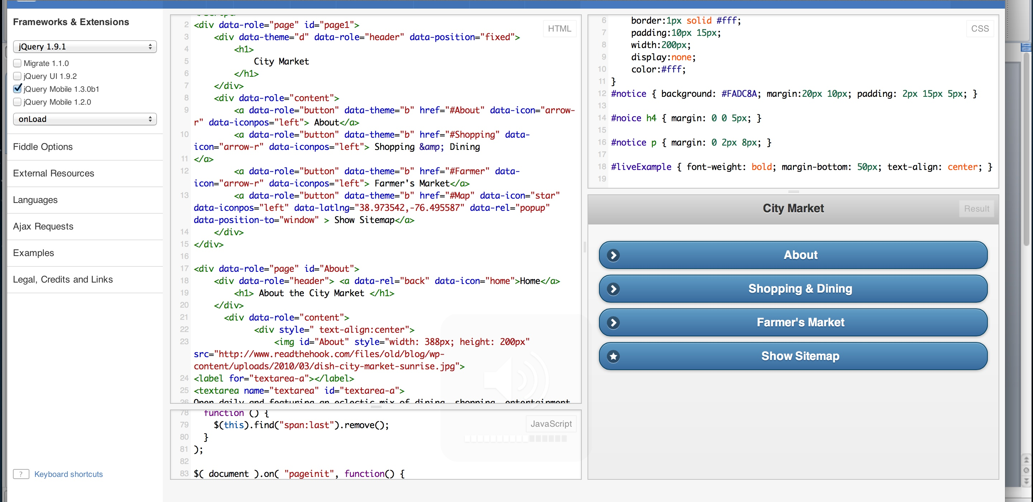First of all, I created all buttons in HTML, and then I added header and elements for each button.
2. I created a java script code and CSS for option choice color.

